Lab No#1
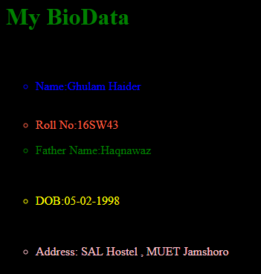

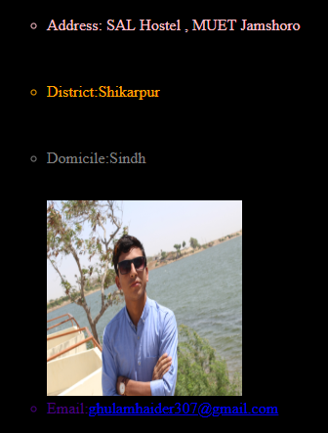
<body bgcolor="black" >

<h1> <p style="color: green">My BioData</p></h1>
<br>
<ul type="circle">
<li style="color: blue" >Name:Ghulam Haider</li>
<br>
<li style="color: tomato"><p>Roll No:16SW43</p></li>
<li style="color: green"><p>Father Name:Haqnawaz</p></li>
<br>
<li style="color: yellow"><p>DOB:05-02-1998</p></li>
<br>
<li style="color: pink" ><p>Address: SAL Hostel , MUET Jamshoro</p></li>
<br>
<li style="color: orange"><p>District:Shikarpur</p></li>
<br>
<li style="color: gray"><p>Domicile:Sindh</p></li>
<br>
<img src="my.jpg" title="My Profile" height="200" width="200">
<br>
<li style="color: indigo"> Email:<a href="MAILTO:ghulamhaider307@gmail.com">ghulamhaider307@gmail.com</a></li>

</ul>

<body bgcolor="">
<center>
<h1>Application Form</h1>
<form>

<h1>User Name:<input type="text" name="" value="Type your name here" style="clip: green"></h1>
<br>
<br>
<br>
<h1>Password :<input type="Password" name="" value="Type your password here" style="clip: blue;"></h1>
<br>
<br>
<br>
<h1>Remember me:<input type="checkbox" name="" style="color: green"></h1>
<br>
<br>
<h1><input type="Submit" name="" value="Login" style="color: green"></h1>
<br>

</form>
</center>

